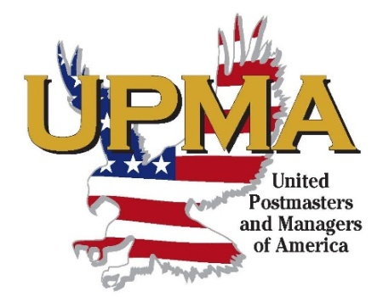

UPMA Wisconsin Chapter Scholarship FAQ’s-2017

What Scholarships are available? The members of UPMA Wisconsin Chapter sponsor four $1000 scholarships each year.

Who is eligible to apply? An applicant must be a child, stepchild, ward, grandchild or step grandchild of an active, retired, or deceased UPMA Wisconsin Chapter Postmaster, AND all of the following…
1. Is a High School Graduate who is accepted as a FIRST YEAR STUDENT for fall admission to an accredited College, University, or Technical School. (Per UPMA Wisconsin Chapter Scholarship By-Laws Section 5a)
2. The applicant must be maintaining a “C” grade average, be capable of pursuing further education and must be capable of providing means for his/her living expenses while attending school either from his/her own funds or reasonable assurance of earning same while in school. (Per UPMA Wisconsin Chapter Scholarship By-Laws Section 5a)

What documentation must be submitted to apply for a Scholarship?
1. A completed UPMA Wisconsin Chapter Scholarship application signed by both the applicant and a parent.
2. On an additional sheet of paper, please write a biographical sketch outlining your background, your decision to pursue higher education, and your future once you complete your education.
3. Submit a copy of your scholastic grades and attendance record.
4. Submit a copy of your SAT and/or ACT scores if these exams were taken.
5. Furnish an endorsement from a responsible person not related to you, who has had an opportunity to personally observe you, and who can offer a worthwhile opinion of your character, and work ethic.

**IMPORTANT NOTE: Without the UPMA Wisconsin Chapter Scholarship application fully completed and ALL of the documentation described above, your application cannot be thoroughly evaluated. Your incomplete application packet will not be advanced to the judges. The missing documentation or a second application attempt will not be accepted after the application deadline.

How will the Scholarships be awarded? The committee’s recommendation need not be governed by need alone. Each application will be judged individually, taking into consideration the factor of ability, proven performance, community involvement, the sincerity of purpose and the need of cultivation of the applicant’s initiative and ambitions.

How are the Scholarship applications judged? There is a great deal of effort put into maintaining the integrity of the Scholarship program. The Scholarship Chairperson selects 5 Judges from various areas of the state to judge the submitted applications. Only the Scholarship Chairperson knows who the Judges are. These Judges cannot adjudicate the application of a relative. Once all applications are received and recorded by the Chairperson, they will be sent on to the Judges for review. The packet of Scholarship applications to be judged is mailed to Judge #1. Judge #1 then returns his/her ballot rating the applications in the order he/she prefers. The application packet is then mailed onto Judge #2 and so on until all Judges get an opportunity to review and rate the scholarship applications. Once the applications have been circulated through all of the judges, the ballots are tabulated; the Scholarship Chairman verifies the ballot results and begins the notification process.

After a Scholarship is awarded, how does the recipient go about receiving the payment?

- The UPMA Wisconsin Chapter Scholarships are paid in two equal payment of $500 each.

The recipient must submit proof of enrollment for fall admission to an accredited College, University, or Technical College to the Scholarship Chairperson. Because students can be accepted to several colleges, the enrollment letter from the College, University or Technical College you will actually be attending is required showing which classes you are enrolled in is required documentation. To receive the second $500 payment, the recipient must provide their grade transcript from their first semester. This documentation to support the scholarship payments should be sent to: Peg Szymanski, Chairperson, UPMA Wisconsin Chapter Scholarship Program, W7641 Evergreen Ave., Westfield, WI 53964-8247. Phone (608)-296-3653
- In turn, the Scholarship Chairman submits a voucher to the President for her/his signature and onto the
Secretary/Treasurer for payment.
If you should have any other questions, contact Scholarship Chairperson Tom Derey at 608-697-1502 (Cell) or email tdderey@charter.net
Submit your application with all required supporting documentation to the
Scholarship Chairperson:

Peg Szymanski,

UPMA Scholarship Program

W7641 Evergreen Ave.

Westfield, WI 53964-8247

The deadline is April 1, 2017. All applications must be postmarked by this
date. Applications with a Postmark later than April 1, 2017 will not be considered and will be returned unopened. As a minimum, it is suggested that you send your application via Priority Mail with Delivery Confirmation or similar service.

